PDE 1823 – Physical Computing and Coding

Project Documentation: Sob 27,28,29,30

Topic: Mini project -Mickey calculator

Tutor: Engie Bashir & Zaid Burhani

Introduction/problem:

Make a calculator program with basic math function ( +,-,/,x etc )and advanced functions like (multiple finder, Boolean converter , prime number checker etc) and explain the code.

Program Functionalities:

My mini program mickey calculator can perform any basic math calculations with help of python in-built functions like multiplication,addition,division etc. For the advanced functions I have made functions that can help calculation easier for the user. Like prime number checker: which will tell whether a number is a prime number or not. It will help save time in while doing division or prime factorization. Second example is Boolean converter: which will convert boolean number to whole number. Third advanced function: Boolean checker; it can check whether a number is zero or not, which can help sorting data with a greater number of zeros. Forth function is multiple finder; it can find multiples of various numbers, thus making multiplication and division easier for large numbers. Fifth and last advance function is unit converter: in my program it converts cm to m, which is most useful function according to me, since it saves time for small calculations, which can make taking measurement seamless and fast.

Flow chart:

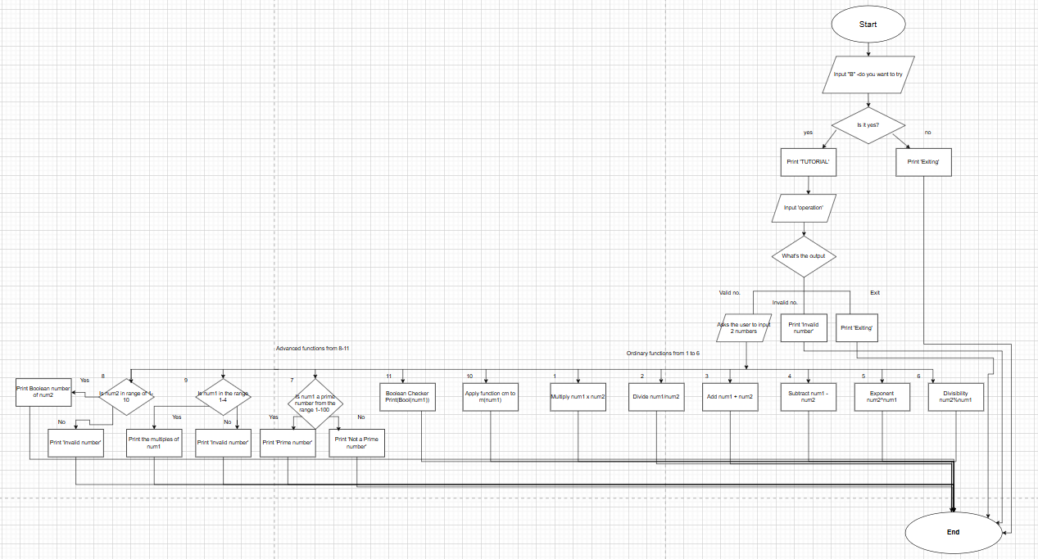

This flowchart was created by me with the help of draw.io.

Explanation : Algorithm

In the start of the program, I provide to the user a question ‘Do you want to try’ if the user answers yes then the program, displays the tutorial to use the mickey calculator, if user types anything except this, then they exit the program. After the tutorial, another question is printed ‘What operation you wish to execute’. If the user inputs the correct number, then the operation will ask the 2 numbers on which operation takes place. if user inputs a wrong number, the program will print invalid number. If the user doesn't want to continue using the program, then they can type ‘Exit’ and leave the program. After typing the numbers, the desired operation will be executed and answer will appear on the output screen and program will end. For ordinary functions, In-built math functions in python are used, so has almost no limitation for any number, which is inputted according to tutorial. But for Advanced functions there are some limitations because large amount of data can take up user’s laptop memory and time. As long as the user follows the rules & limits for the input number in advanced operations, The answer will appear on the output screen. if the user didn't adhere to the rules for advanced operations, ‘invalid number’ will be printed. Advanced operations in program are boolean converter, prime number checker (in boolean converter, the input number will be checked against the boolean data and corresponding value will be printed in the answer & in Prime number checker also input number is checked against data, but answer will depend on the presence of number in prime number data (whether yes or no)),boolean checker ( uses python in-built function bool which differentiates whether a number is 0 or any other number and prints false or true accordingly),multiple finder ( this operation is similar to boolean converter and checks the number against data and if number matches, the planned input is printed) and unit converter ( it takes the inputted value (cm) and applies the function designed by me to convert it into meters and prints the answer).

Pseudocode:

1. BEGIN

2. prompt user for input "I can do simple math functions and some advanced functions, would you like to try, Type yes to proceed"

3. store input in variable B

4*) IF B.lower() == 'yes' then

5 ) PRINT tutorial

6 ) WHILE True :

7!) prompt user for input "Choose an operation or type 'Exit' to quit: "

8 ) store input in variable operation

9 !) IF operation.lower() == 'exit' then

10) PRINT "Exiting"

11) BREAK loop

12!) ELSE IF operation is in ['1', '2', '3', '4', '5', '6', '7', '8', '9', '10', '11'] then

13) prompt user for input “Enter the first number: “

14) store input in variable num1

15) prompt user for input “Enter the second number:”

16) store input in variable num2

17) IF operation == '1' then

18) PRINT result of num1 * num2

19) ELSE IF operation == '2' then

20) PRINT result of num1 / num2

21) ELSE IF operation == '3' then

22) PRINT result of num1 + num2

23) ELSE IF operation == '4' then

24) PRINT result of num1 - num2

25) ELSE IF operation == '5' then

26) PRINT result of num1 ^ num2

27) ELSE IF operation == '6' then

28) PRINT result of num1 % num2

29)ELSE IF operation == '7' then

30) IF num1 is in the list of prime numbers then

31) PRINT "Prime number"

32) ELSE

33) PRINT "Not a prime number"

34) ELSE IF operation == '8' then

35)TRY to find the index of num2 in boolean list

36) IF found then

37) PRINT the index

38)ELSE: PRINT "Invalid number"

39) ELSE IF operation == '9' then

40) MATCH num1 with cases

41)CASE 1:

42) PRINT '1'

43) CASE 2:

44) PRINT '1,2'

45)CASE 3:

46) PRINT '1,3'

47)CASE 4:

48)PRINT '1,2,4'

49)default:

50) PRINT "Invalid number"

51)ELSE IF operation == '10' then

52) DEFINE function Convert_cmtom(cm)

53) RETURN cm / 100

54)CALL Convert_cmtom with num1

55) PRINT result in meters

56)ELSE IF operation == '11' then

57) PRINT boolean value of num1 (True or False)

58!) ELSE

PRINT "Invalid operation, please try again"

59*) ELSE

PRINT "Exiting"

60)END